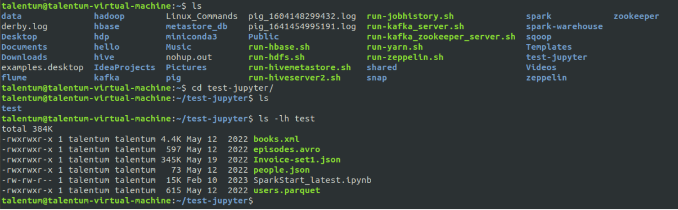

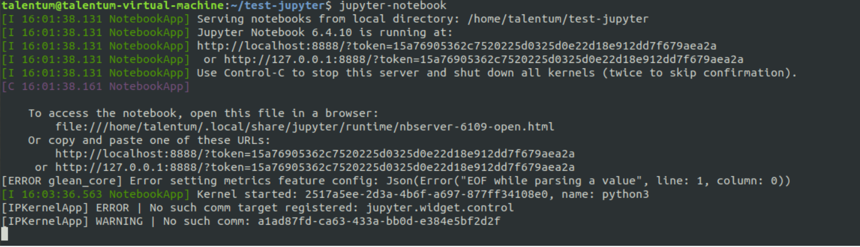

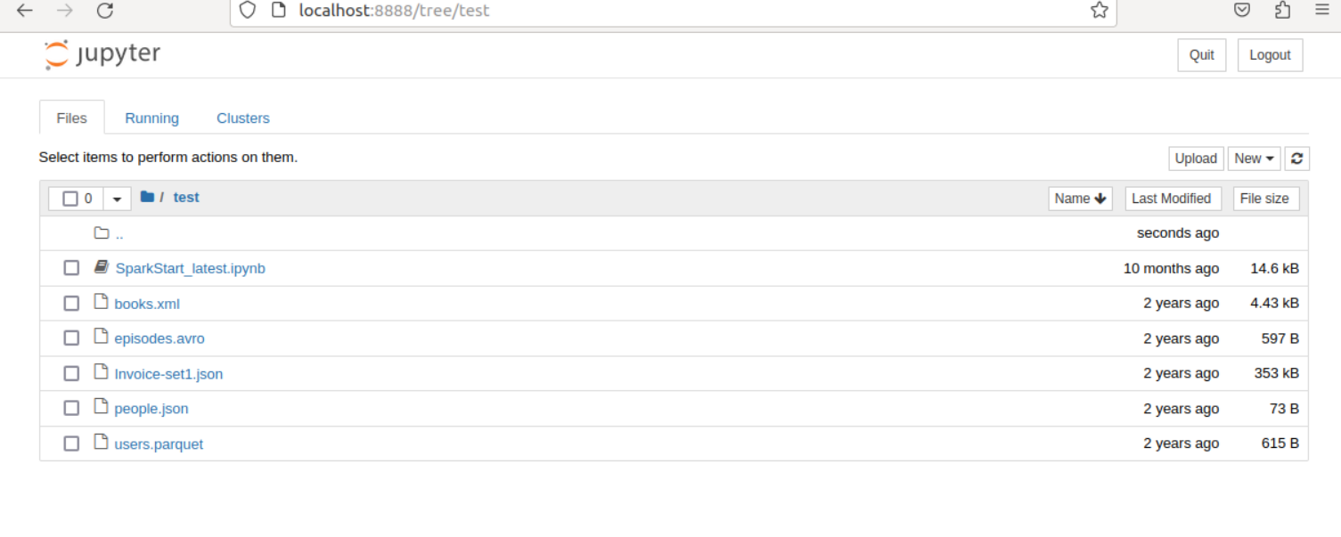

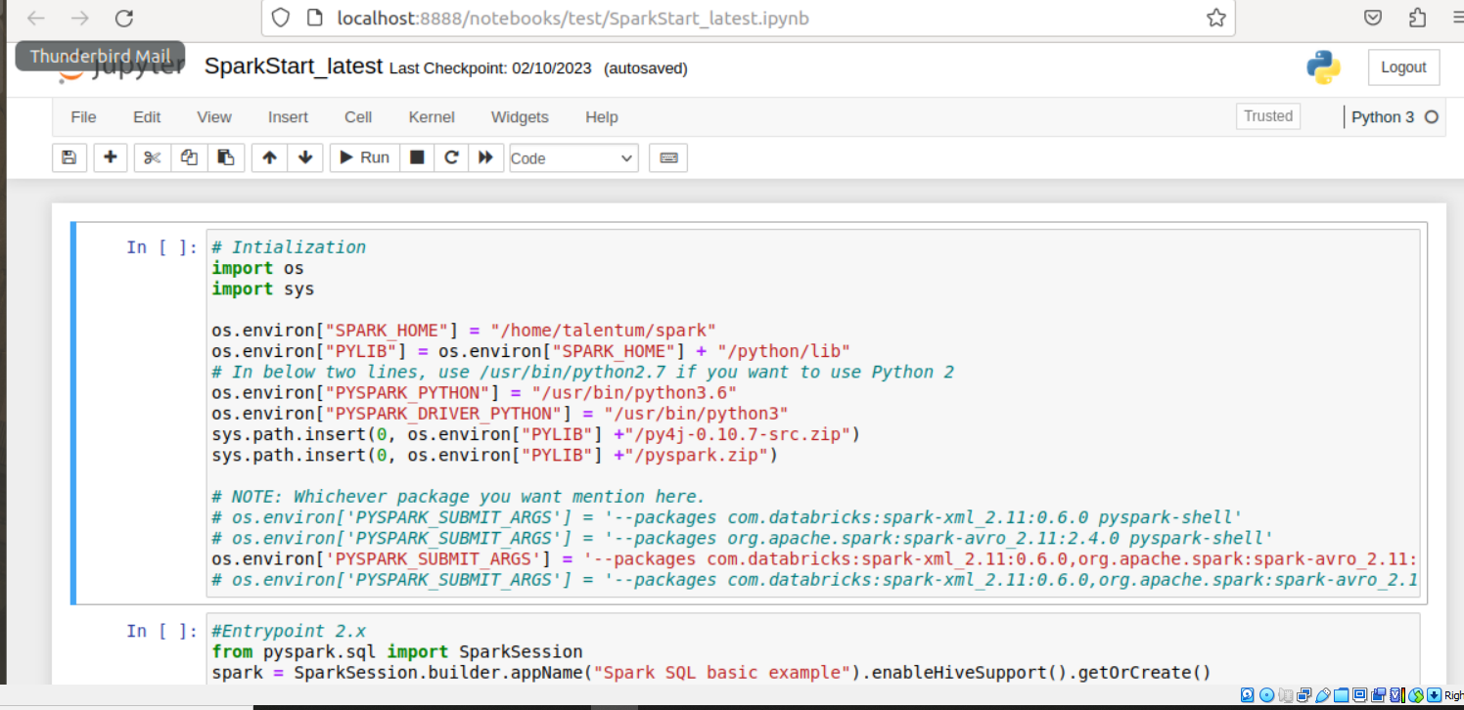

Run it

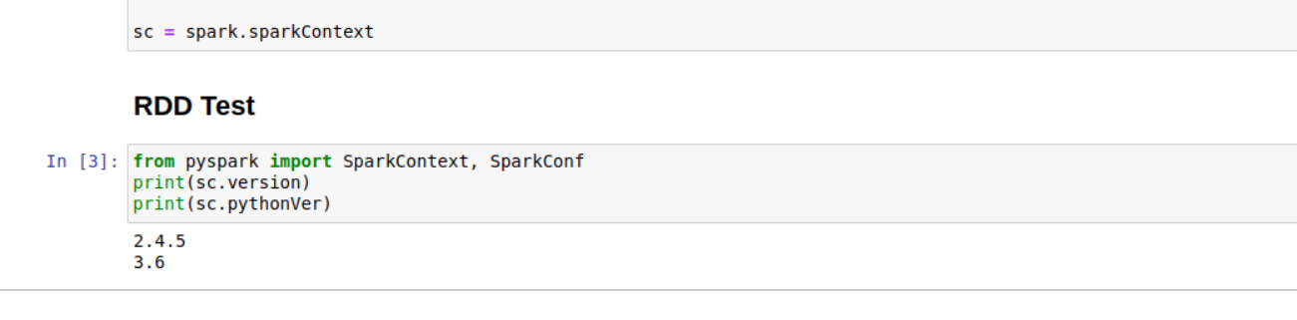

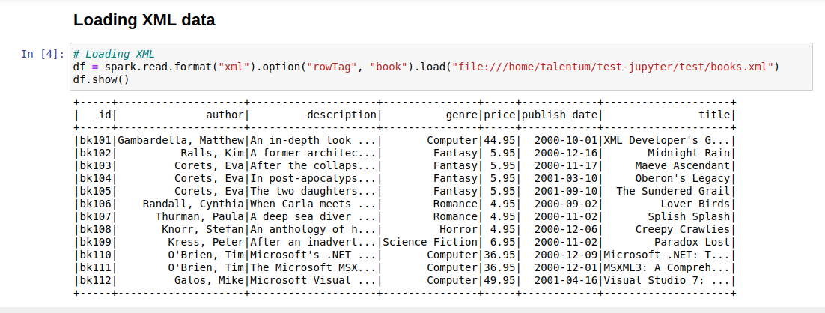

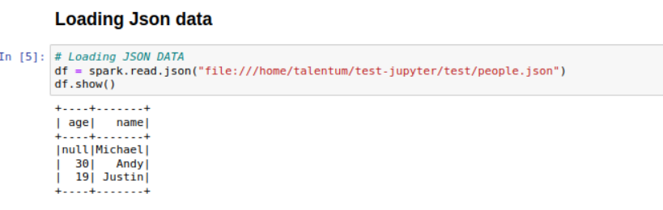

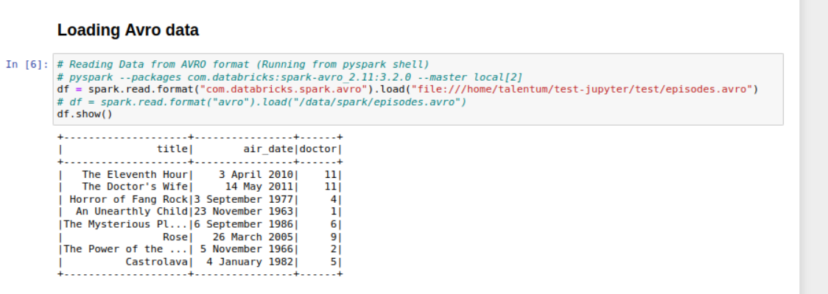

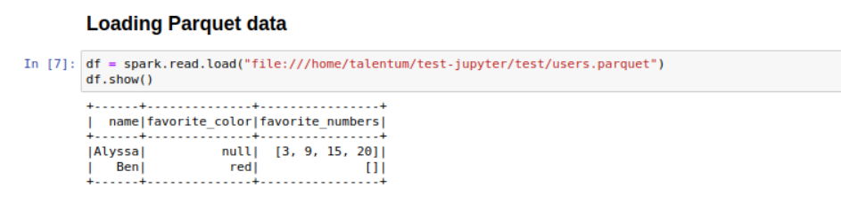

1] BigData Fundamentals With Pyspark (M1 -> Introduction to Big Data analysis with Spark)

(M1->SM1)

1) Download the attached note in STAGING_AREA

2) Create a folder UBUNTU_HOME/test-jupyter/P2/M1/SM1 in Ubuntu machine

3) Pull the note in above location from your STAGING_AREA

4) Open it in Jupyter Notebook running on Ubuntu Machine

* Code/Dataset

data/1_Whatisbigdata.zip

**TimeLine -** 5 Mins

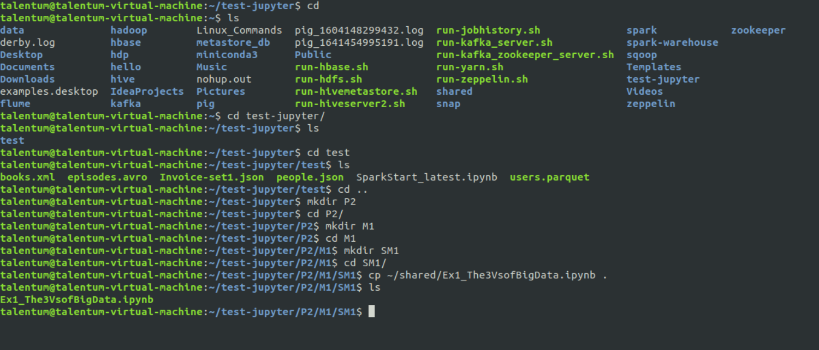

To open spark scala shell

Spark-shell -> command

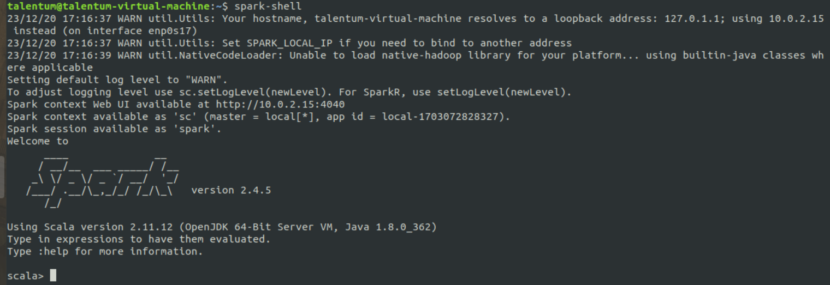

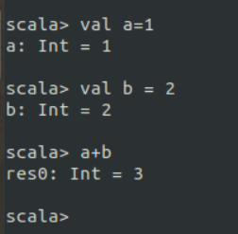

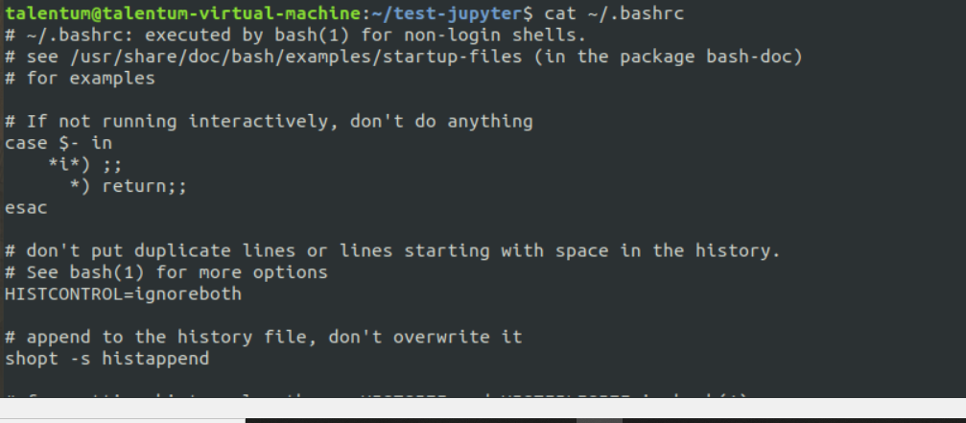

Unset

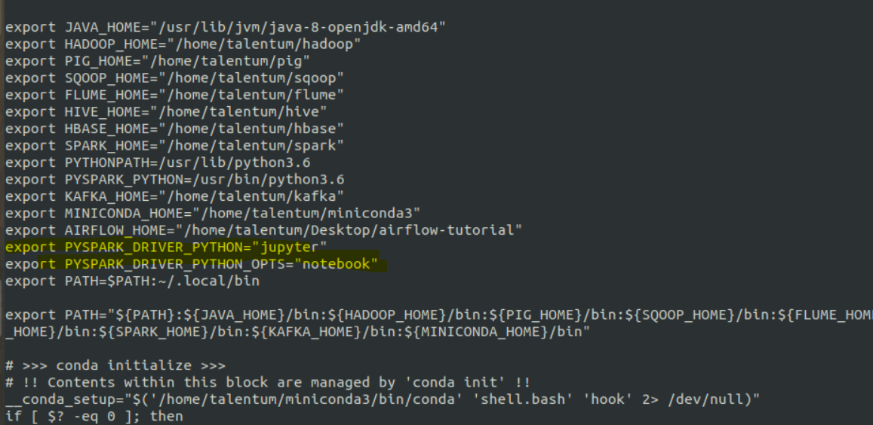

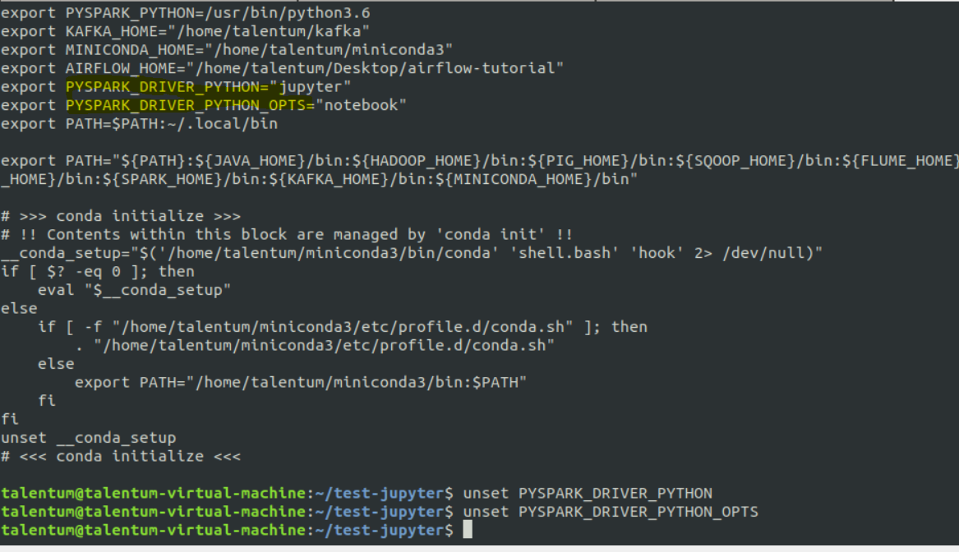

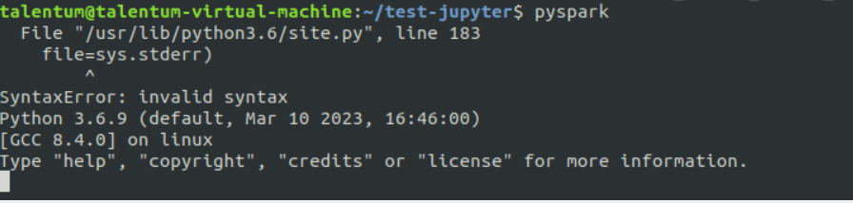

Now it will launch spark python shell

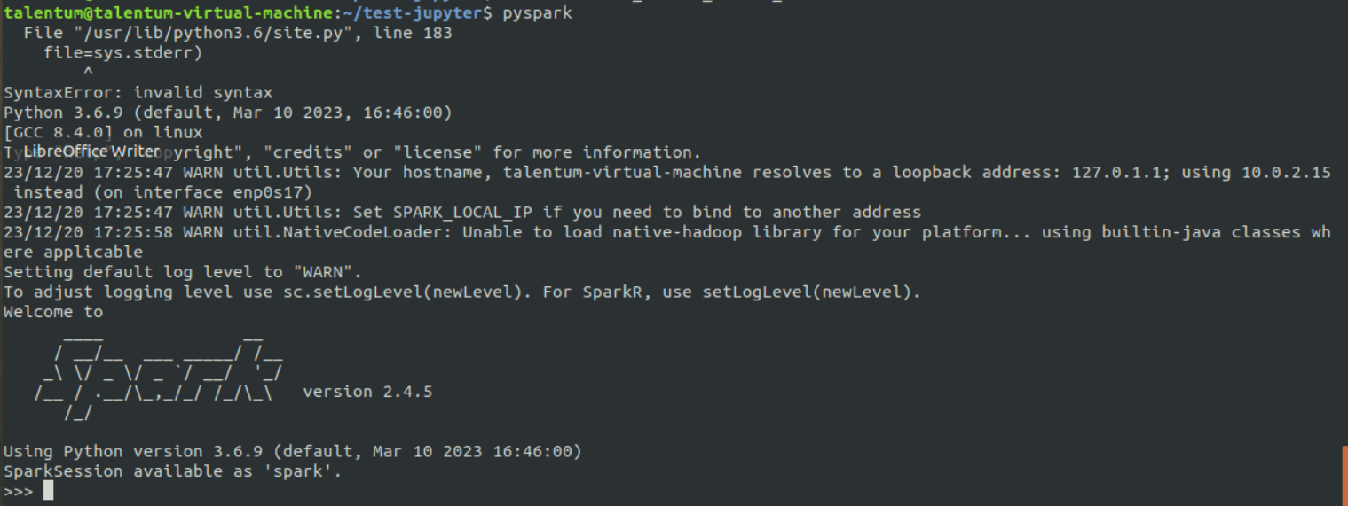

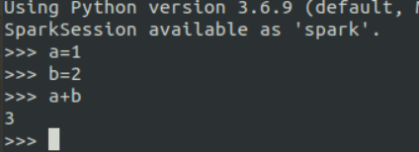

Spark Context SC

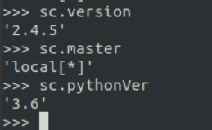

2] BigData Fundamentals With Pyspark (M1 Introduction to Big Data analysis with Spark)

PySpark: Spark with Python (M1->SM2)

1) Download RAR on STAGING_AREA

2) Extract the RAR

3) Put the Jupyter notes in UBUNTU_HOME/test-jupyter/P2/M1/SM2

4) Import the notes in Jupyter Notebooks

5) Follow the instructions in the notes and give the solutions

* Code/Dataset -

data/2_Pyspark-SparkWithPython.rar

Time = 20 Mins.

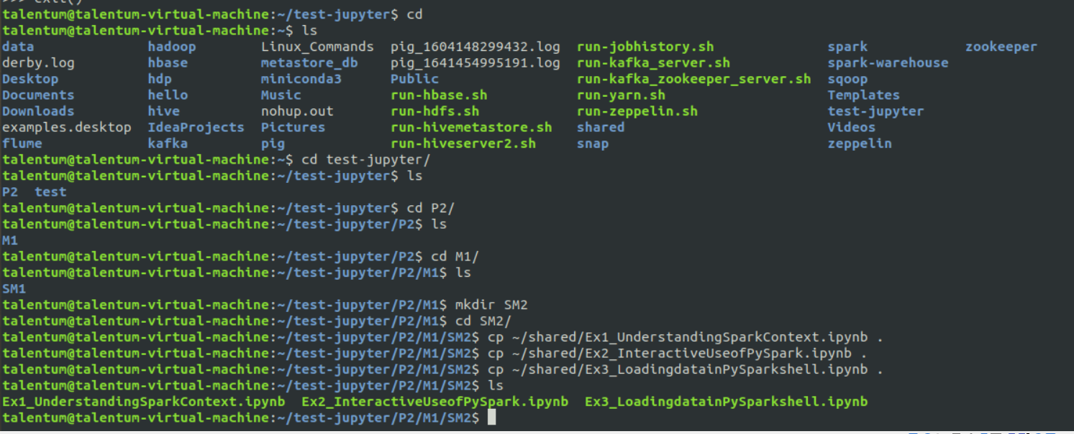

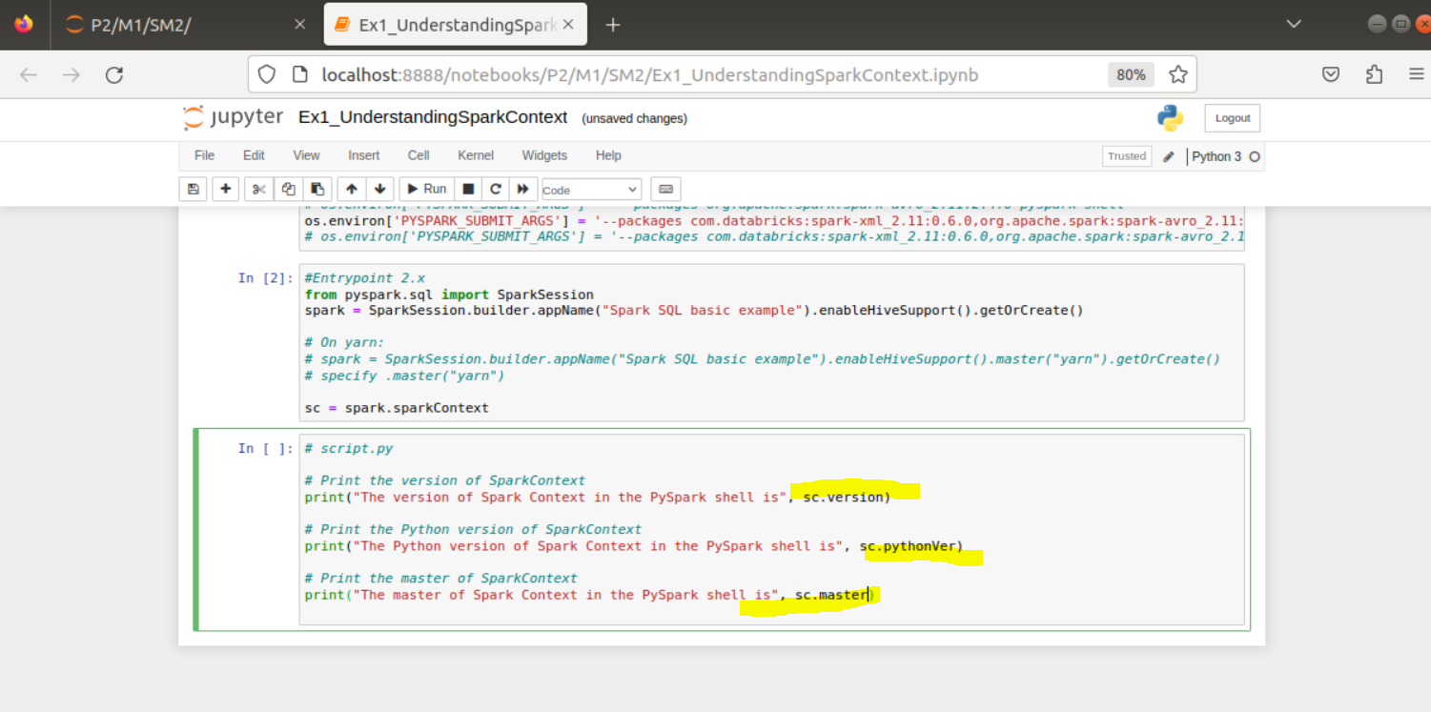

Run

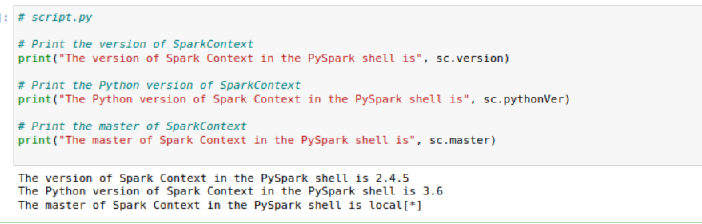

Stop

Start 2nd

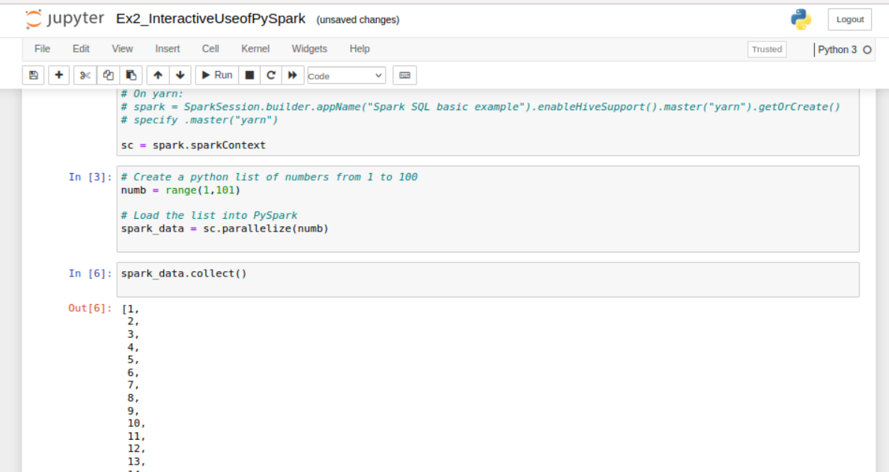

Stop

Start third

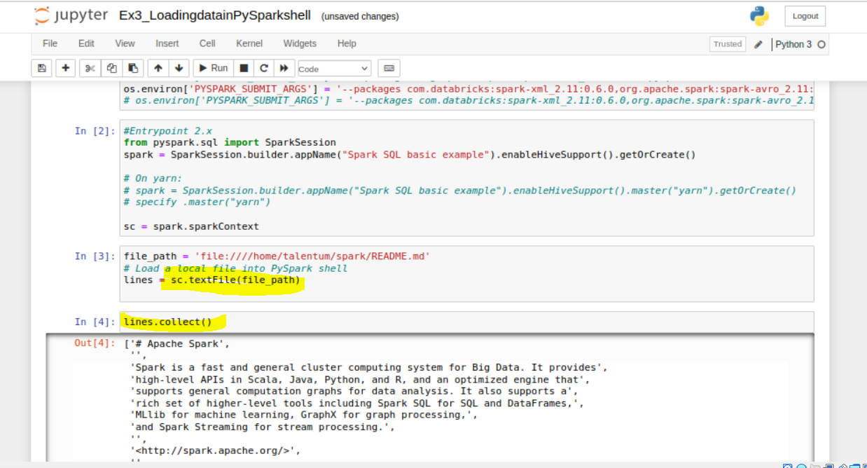

Trying same commands in pyspark

First unset PYSPARK_DRIVER_PYTHON

Unset PYSPARK_DRIVER_PYTHON_OPTS

